PE_PRN221_SU24TrialTest
SUMMER 2024
Subject: PRN221
Duration: 90 minutes

INSTRUCTIONS
Please read the instructions carefully before doing the questions.
- You are NOT allowed to use any other materials. You are NOT allowed to use any device to share data with others.
- You must use Visual Studio 2019 or above, MSSQL Server 2008 or above for your development tools.
IMPORTANT – before you start doing your solution, MUST do the following steps:
- Create Solution in Visual Studio named PRN221PE_SU24TrialTest_StudentName. Inside your Solution, the Project ASP.NET Core Razor Page must be named: OilPaintingArt_StudentName.
- Create your MS SQL database named OilPaintingArt2024DB by running code in script OilPaintingArt2024DB.sql.
- Set the default user interface for your project as a Login page.
- To do your program, you must use ASP.NET Core Razor Pages. Note that you are not allowed to connect directly to the database from Razor Pages, every database connection must be used through Repository and Data Access Objects. The database connection string must get from the appsettings.json file.
In the case your code connects directly to the database from ASP.NET Core Razor Pages or hard coded the connection string, you will get 0 point.
- If there are syntax errors or compilation errors in your PE program, you will not pass the PE requirements, the mark will be 0.
- Your work will be considered invalid (0 point) if your code inserts stuff that is unrelated to the test.

Create an application using ASP.NET Core Razor Pages with .NET Core (.NET 5/.NET 6/.NET 7/.NET 8), C#, and ADO.NET (or Entity Framework Core). A MS SQL Server database will be created to persist the data and it will be used for reading and managing data.
A part of OilPaintingArt2024DB database.
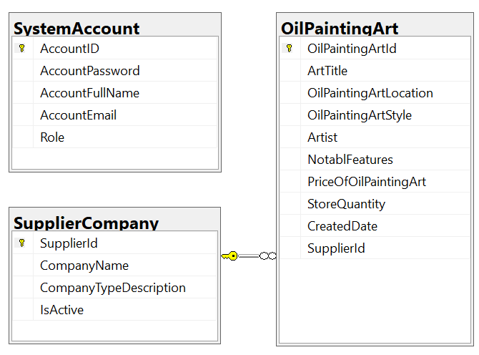
Store account role: Administrator = 1; Staff = 2; Manager = 3; Customer = 4

- (1.0 point) Authentication function. Using AccountEmail and AccountPassword for the authentication/authorization process.
If the user with a Manager Role or Staff Role logs in successfully, save this information to a temporary parameter. In case the login is unsuccessful, display the message “You do not have permission to do this function!”.
- All CRUD actions are required with Manager role,
- Staff role is required for only Read action.

- (2.0 points) Check if login is successful (Staff or Manager role), list all of items in OilPaintingArt table (each record includes information of oil paintings and CompanyName). Paging is required for this function, 2 records/1page.

- (1.0 point) If a user with Manager role logs in successfully, search all items with 2 conditions: OilPaintingArtStyle, Artist (OR option for this case and using relative search).

- (1.0 point) If a user with Manager role logs in successfully, delete the selected item with the confirmation then update the list of items.

- (3.0 marks) If a user with a Manager role logs in successfully, add a new item with the requirements:
- The new item will display at the top of the list.
- All fields are required.
- Value for StoreQuantity > 0 and <= 50.
- Value for ArtTitle is greater than 4 characters. Each word of the ArtTitle must begin with the capital letter. The value of ArtTitle is not allow numbers (0, 1, 2 →9) but allows special characters such as @, $, &, (, ).
- Value for CreatedDate is the time when create a new item and set default value for CreatedDate = current date. CreatedDate can’t update.
- The SupplierId/CompanyName will come from the SupplierCompany table (you can use ComboBox UI control in this case)

- (2.0 mark) If a user with Manager role logs in successfully, update the selected existing item.
- With update function, the same validation requirements with Add function.

